Universal Design Research Assignment

* Read through each of the profiles below and summarise the work of each person.
* Write a paragraph on the similarities you have found across each of the four.
* What would you consider to be the most important features for users?

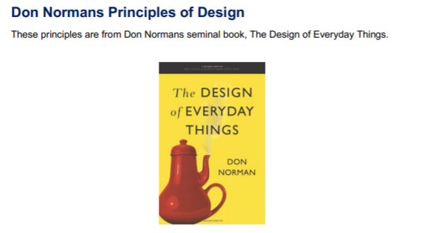

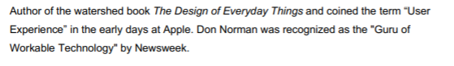

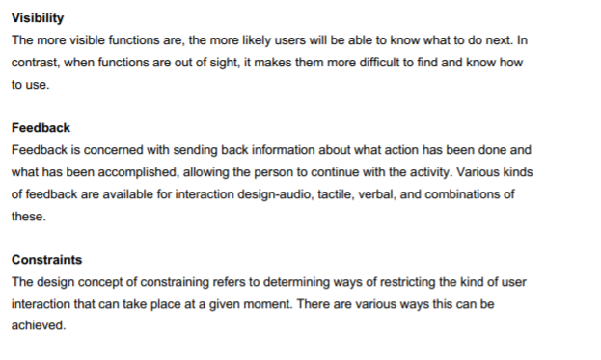

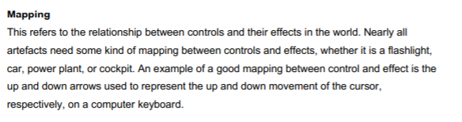

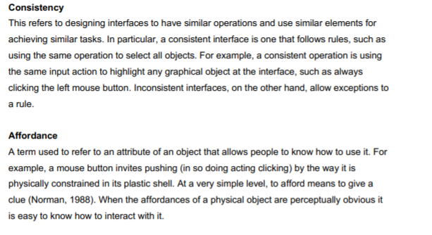

**Jakob Nielsen**

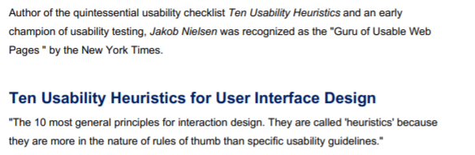

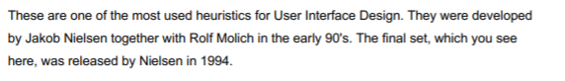

[**https://www.youtube.com/watch?v=hWc0Fd2AS3s&feature=youtu.be**](https://www.youtube.com/watch?v=hWc0Fd2AS3s&feature=youtu.be)

1. **Visibility of system status**

The system should always keep users informed about what is going on, through appropriate feedback within reasonable time.

1. **Match between system and the real world**

The system should speak the users’ language, with words, phrases and concepts familiar to the user, rather than system -oriented terms. Follow real-world conventions, making information appear in a natural logical order.

1. **User control and freedom**

Users often choose system functions by mistake and will need a clearly marked “emergency exit” to leave the unwanted state without having to go through an extended dialogue. Support undo and redo.

1. **Consistency and standards**

Users should not have to wonder whether different words, situations or actions mean the same thing. Follow platform conventions.

1. **Error prevention**

Even better than good error messages is a careful design which prevents a problem from occurring in the first place. Either eliminate error-prone conditions or check for them and present users with a confirmation option before they commit the action.

1. **Recognition rather than recall**

Minimize the user’s memory load by making objects, actions and options visible. The user should not have to remember information from one part of the dialogue to another. Instructions for use of the system should be visible or easily retrievable whenever appropriate.

1. **Flexibility and efficiency of user**

Accelerators - unseen by the novice user- may often speed up the interaction for the expert user such that the system can cater for both inexperienced and experienced users. Allow users to tailor frequence actions.

1. **Aesthetic and minimalist design**

Dialogues should not contain information which is irrelevant or rarely needed. Every extra unit of information in a dialogue competes with the relevant units of information and diminishes their relative visibility.

1. **Help users recognize, diagnose and recover from errors**

Error messages should be expressed in plain language (no codes), precisely indicate the problem, and suggest a solution.

1. **Help and documentation**

Even though it is better if the system can be used without documentation, it may be necessary to provide help and documentation. Any such documentation should be easy to search, focus on the user’s task, list concrete steps to be carried out and not be too large.

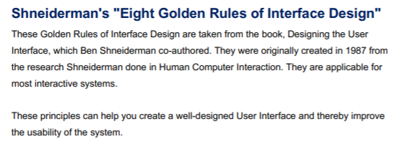

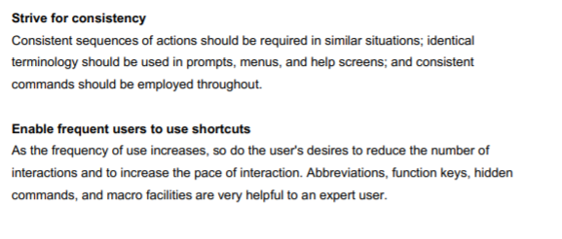

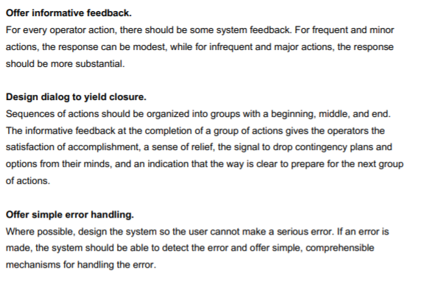

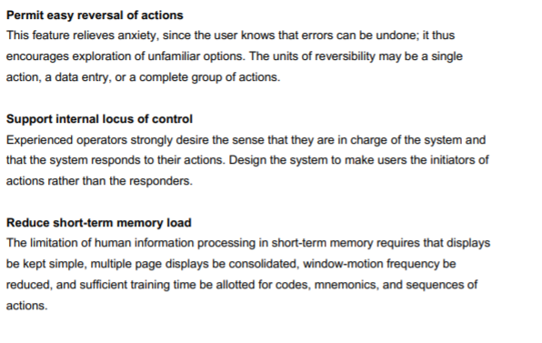

Source: Designing the User Interface: Strategies for Effective Human-Computer Interaction



